

VISVESVARAYA TECHNOLOGICAL UNIVERSITY Jnana Sangama, Machhe, Belagavi, Karnataka 590018

18ISL67 - FILE STRUCTURES LABORATORY WITH MINI-PROJECT REPORT On

PROPERTY MANAGEMENT SYSTEM-HASHING WITH BUCKETS

Submitted in partial fulfillment of the requirement for the award of the degree of

Bachelor of Engineering in
Information Science & Engineering by

Anish Kumar Piyush Singh
Tushar Prakash
(1BG20IS008) (1BG20IS034) (1BG20IS060)

B.N.M. Institute of Technology An Autonomous Institution under VTU, Approved by AICTE
Department of Information Science and Engineering 2022 – 2023

B.N.M. Institute of Technology An Autonomous Institution under VTU

DEPARTMENT OF INFORMATION SCIENCE & ENGINEERING

CERTIFICATE

Certified that the Mini-project entitled property management system is carried out by

Mr. Anish Kumar USN 1BG20IS008, Mr. Piyush Singh USN 1BG20IS034, Mr. Tushar

Prakash USN 1BG20IS060 the bonafide student of B.N.M Institute of Technology in partial fulfillment for the award of Bachelor of Engineering in Information Science & Engineering of the Visvesvaraya Technological University, Belagavi during the year 2022-2023. It is certified that all corrections / suggestions indicated for Internal Assessment have been incorporated in the report deposited in the department library. The mini-project report has been approved as it satisfies the academic requirements in respect of mini-project prescribed for the said Degree.

Mrs. Laxmi V / Mrs. Kavya N L Asst. Professor, Dept. of ISE BNMIT
Dr. S Srividhya
Prof & Head, Dept. of ISE BNMIT

Name & Signature of the Examiners with date:

1.

2.

List of Figures

Chapter No.

2

4

6
Figure No.

Fig.2.1

Fig.4.1 Fig.4.2 Fig. 4.3 Fig. 4.4 Fig.6.1 Fig.6.2 Fig.6.3 Fig.6.4 Fig.6.5 Fig.6.6 Fig.6.7 Fig.6.8 Fig.6.9 Fig.6.10 Fig.6.11 Fig.6.12 Fig.6.13 Fig.6.14
Fig.6.15
Description

Hash Table with example

Keys loaded into has file Bucket contents Architecture Design Data flow diagram Registration Page Login Page Menu Page
Add Operation Page Delete Operation Page Search Operation Page Property Result Main Menu
Buy Property Operation Return Property Operation User Credential Details Data save hash form
Record location in hash form Borrower Relationship
Simple indexing of user profile
Page No.

07

12 12 13 14 18 18 19 19 20 20 21 21 21 22 22 23 23 24
24

List of Tables

Chapter No.

3
Table No.

3.1
Description

Software Requirements
Page No.

8

3.2 Hardware Requirements 9

CHAPTER 1

INTRODUCTION

1.1 Objective

A property management system (PMS) is a software solution designed to help propertymanagers and landlords streamline and automate various tasks related to managing properties. It typically includes features such as rental property listings, tenant management, lease tracking, maintenance requests, financial management, and reporting. To maintain client details line contact details, required property details, client type like residential and commercial client & price limit. To maintain property details, registration of property for sale includes property address, property description, price, facilities available.
1.2 Scope

The scope related to property management system (PMS) refers to the organization and structureof digital files and documents within the system. Here are some aspects within the scope of file structure in a PMS:
• Property Information: The PMS stores property-related information, such as property details, descriptions, photos, and floor plans. The file structure should include appropriate folders and subfolders to categorize and organize this data.
• Financial Records: The PMS handles financial transactions, so the file structure should accommodate financial records, including invoices, billing statements, and financial reports. These files should be organized in a way that enables efficient tracking and retrieval.
• Maintenance and Repair Documentation: Property maintenance and repair records, including work orders, service contracts, and maintenance schedules, should be structured within the file system. This allows propertymanagers to easilylocate and refer to these documents when needed.

1.3 Motivation

The motivation behind implementing a property management system (PMS) can be Revenue Optimization can help property owners and managers optimize revenue generation. With features like integrated channel management, rate management, and real-time availability updates, a PMS ensures optimal pricing, maximizes occupancy rates, and

Dept. of ISE, BNMIT 2022-23 Page 5
Implementation of Hashing with Buckets

enables effective revenue management strategies. Efficiency and Streamlined Operations

is the primary motivations for adopting a PMS is to improve operational efficiency. By automating and streamlining various propertymanagement processes, such as reservations, check-ins, maintenance requests, and billing, a PMS can save time, reduce manual errors, and enhance overall productivity. Behind implementing a property management system revolves around improving efficiency, enhancing guest satisfaction, optimizing revenue, gaining data-driven insights, and ensuring compliance and security. By leveraging technology and automation, a property management system offers numerous benefits to property owners and managers, making it a valuable tool in today's competitive property management landscape.

Dept. of ISE, BNMIT 2022-23 Page 6
CHAPTER 2

METHODOLOGY

2.1 Hashing with Buckets

Hashing is the process of transforming any given key or a string of characters into another value. This is usually represented by a shorter, fixed-length value or key that represents and makes it easier to find or employ the original string.
In computing, a hash table [hash map] is a data structure that provides virtually direct access to objects based on a key [a unique String or Integer]. A hash table uses a hash function to compute an index into an array of buckets or slots, from which the desired value can be found. Hashing ideallyoffers O(1) time complexityfor disk access, but the hash function can map more than one record to the same address location causing collision. Usage of buckets is one of the collision resolution technique used.

Bucket= block of records corresponding to one address in the hash table. The hash function gives the BUCKET ADDRESS.

Example: for bucket holding 3 record, if we insert the following keys:

KEY ADDRESS

JAMES 33

JORDAN 33

NIKOLA 33

KOBE 33

Fig. 2.1 Hash Table

Keys ‘JAMES’,’JORDDAN’ and ‘NIKOLA’ will be placed in their address and key ‘KOBE’ will be an overflow record.

Dept. of ISE, BNMIT 2022-23 Page 7
Implementation of Hashing with Buckets

2.2 Tools

Language: PYTHON

Python is a popular high-level programming language known for its simplicity, readability, and versatility. It was created by Guido van Rossum and first released in 1991. Python emphasizes code readability with its clean and intuitive syntax, making it easier for beginners to learn and understand.
Python is an interpreted language, which means that it is executed line by line. There is no need for a sepate compilation step, making development and testing Python uses dynamic typing, allowing variables to hold values of any type. Variable types are determined at runtime based on the assigned values. Python has a vibrant ecosystem with a vast collection of third-party libraries and packages. These libraries extend Python's functionality and enable developers to leverage pre-existing solutions. Python is a cross-platform language, meaning it can run on different operating systems like Windows, macOS, Linux, and more. This portability makes it easy to develop applications that can be deployed on multiple platforms.
Python's versatility, ease of use, and extensive ecosystem have contributed to its widespread adoption across various industries and domains. It is widely regarded as an excellent language for beginners and experienced developers alike, fostering rapid development and promoting code readability.

CUSTOM TKINTER
Tkinter is the standard GUI (Graphical User Interface) toolkit for Python. It

provides a set of modules that allow developers to create desktop applications with graphical interfaces. Tkinter is based on the Tcl/Tk framework and provides a Python interface to it.
While Tkinter provides a rich set of GUI components and functionalities, it is also highly customizable. User can customize the appearance and behavior of Tkinter widgets by configuring their properties and options. For example, you can change the size, font, color, and alignment of text in labels, buttons, or entry fields.
With Tkinter, user can create windows, dialogs, buttons, text boxes, labels, and other GUI components. You can define event handlers to respond to user interactions, such as button clicks or menu selections. Tkinter also supports various layout managers to arrange and organize the graphical elements within windows or frames. Tkinter allows you to create custom widgets by sub classing the existing Tkinter classes and extending their functionality.
Dept of ISE, BNMIT 2022-23 Page 8
Implementation of Hashing with Buckets

Tkinter is a mature and widelyused GUItoolkit, but it mayhave certain limitations in terms

of advanced graphical effects or modern UI designs. Tkinter allows you to create custom widgets by sub classing the existing Tkinter classes and extending their functionality. This way, you can create specialized or unique widgets tailored to your specific application's requirements.

SHA256 ENCRYPTION

SHA256 is a widely used cryptographic hash function that generates a 256-bit (32-byte) hash value, typically represented as a hexadecimal string. It belongs to the SHA-2 (Secure Hash Algorithm 2) family of hash functions. In Python, you can perform SHA256 encryption usingthe hashlib module, which provides an interface to various hash functions, including SHA256. Here's a detailed explanation of the steps involved in SHA256 encryption:
• Begin by importing the hashlib module, which is a built-in module in Python.

• Create an instance of the SHA256 hash object using the hashlib.sha256() constructor.
• To encrypt a message with SHA256, you need to convert it to a sequence of bytes. • The next step is to update the hash object with the message bytes. This is done using
the update() method of the hash object.

• After updating the hash object with all the message bytes, you can obtain the resulting hash digest. The hexdigest() method returns the hash digest as a hexadecimal string.
SHA256 encryption is commonly used for various cryptographic purposes, such as data integrity checks, digital signatures, password hashing, and secure storage of sensitive information. It produces a fixed-size output regardless of the size of the input message, making it suitable for hashing large amounts of data efficiently and securely.

Dept of ISE, BNMIT 2022-23 Page 9
CHAPTER 3

SYSTEM REQUIREMENTS SPECIFICATION

3.1 User Requirements

The file system is used to develop a property management system. The terms may be used in real estate, manufacturing, logistics, intellectual property, government, or hospitality accommodation management.They are computerized systems that facilitate the management of properties, personal property, and equipment, including maintenance, legalities and personnel all through a single piece of software. Theyreplaced old-fashioned, paper-based methods that tended to be both cumbersome and inefficient. They are often deployed as client/server configurations. Today, most next-generation property management systems favour a software as a service (SaaS) model sustained by web and cloud technologies.Admin must be able to view all the table present. Admin can add a new property to the system, delete a particular property and search any property by user choice.

3.2 Software Requirements • VS Code
• Python

• Python tkinter custom tkinter • SHA256 encryption
• File processing with python

3.3 Hardware Requirements

• Processor: intel® core™ i5-6500 CPU @ 3.20GHz

• Installed memory (RAM): 8.00 GB (7.88 GB usable)

• System type: 64-bit operating system, x64-based processor.

• Pen and touch: no pen or touch input is available for this display.

Dept. of ISE, BNMIT 2022-23 Page 10
Implementation of Hashing with Buckets

3.4 Functional Requirements

• Whenever the admin adds a new propertydetail it should be inserted in the bdata.txt file.
• New record must be inserted and details are entered.

• Admin should be able to view the details of new property item inserted. • In the display, the property details, its price and locations are displayed.
• The system must respond to user request for the operation supported by the system.

3.5 Non - Functional Requirements

• The application should display appropriate messages to the administrator if something goes wrong like inserted duplicate records
• The application should not crash.

• The user should be able to understand the facilities the application is providing to the user.
• The application should be user friendly.

Dept. of ISE, BNMIT 2022-23 Page 11
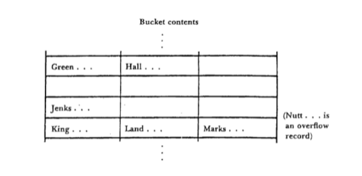
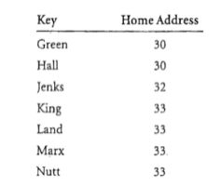
CHAPTER 4

SYSTEM DESIGN AND DEVELOPMENT

4.1 Architectural Design

In computing, a hash table [hash map] is a data structure that provides virtually direct access to objects based on a key[a unique String or Integer]. A hash table uses a hash function to compute an index into an arrayof buckets or slots, from which the desired value can be found.
Hashing ideallyoffers O (1) time complexityfor disk access, but the hash function can map more than one record to the same address location causing collision. Usage of buckets is one of the collision resolution techniques used.
Consider the following set of keys, which is to be loaded into a hash file.

Fig 4.1 Keys loaded into has file

Bucket structure for the records specified above. Each bucket can hold up to three records.

Fig 4.2 Bucket contents

Dept. of ISE, BNMIT 2022-23 Page 12
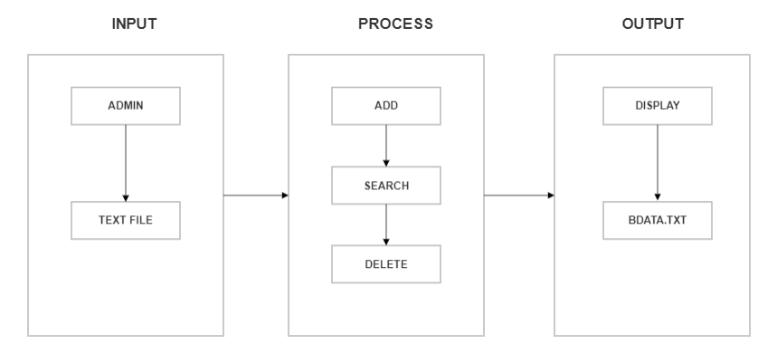
Implementation of Hashing with Buckets

Fig 4.3 Architecture Design

In fig. 4.3, take input data through admin to fill the data will shows in the text file by the

user, in the process of a data user can do the multiple modulation in the data by the add of the property, delete of the property by property id and search will also done with of by the property id by the given input through the user and the output will has been shown in display file to the user and it will basically shows in the (bdata.txt) text file will display to screen to the user by given input data will be put by the user.

Dept. of ISE, BNMIT 2022-23 Page 13
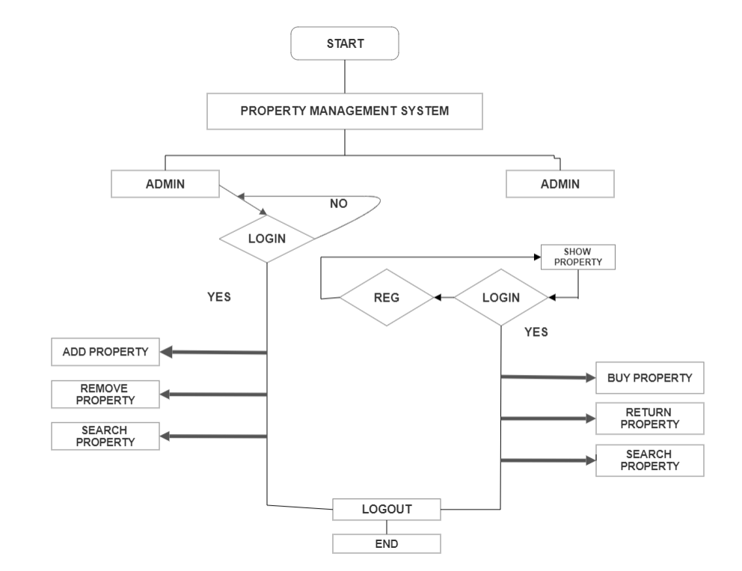
Implementation of Hashing with Buckets

Fig 4.4 Data flow Diagram

In fig. 4.4, the admin gets an option to add property, delete propertyand delete the borrower

id. If the admin selects add item, he has to add all the details about that particular item. When he selects the delete option, he can delete any item present in the menu. When he selects the return option, he can return any field of a particular property to that buyer id. The Buyer can sign in and place his order by selecting the desired item along with its rates. Once he adds the property details to the system, it will displayed all details of property Id after it will also search the property by property id.

Dept. of ISE, BNMIT 2022-23 Page 14
CHAPTER 5

IMPLEMENTATION

5.1 Modules Implemented

Hashing with buckets is an advanced method of file organization. It generates a hash table providing the matching of records with their addresses. The hash table is generated by using a hash function.
The different operations supported by Hashing with buckets and used to implement the Property Management system are listed below:

1) Insert

2) Search 3) Delete

5.2 Description of Module

Insert module is used to insert details of the product to the file created bythe admin. This module inserts the information in an organized manner that is pre-defined and helps in proper management of all the information. Insertion is done usingthe collision resolution technique-hashing with buckets.
A search function in a file structure allows you to find files or directories based on specific criteria. It involves traversing the file structure, comparing properties like file names, extensions, or content with the specified search criteria, and returning matches. The function scans through the structure recursively, locating relevant files or directories that meet the search conditions.
Delete module is used to delete a particular record that is stored in the file by using the name of that product. The admin can remove products off the menu and could remove a user as well.

Dept. of ISE, BNMIT 2022-23 Page 15
IImplementation of Hashing with Buckets

5.3 Algorithm

Insert: In the insert function, hashing using buckets as collision resolution is being implemented. The item id, name, quantity and price are entered by the admin. The id is passed through a hash function which will generate a hash value. If the value is even it is inserted into bucket1 (file1.txt) and if it is odd it is inserted into bucket2 (file2.txt). If the bucket value exceeds 5, “Bucket overflow” message is displayed and finally the contents are inserted into Bdata.txt file.

1. Start

2. Details of property are entered through the frontend 3. Check if property already present
A) if yes show "Property already present", go to step 6 B) else go to step 4
4. Location in the hash table database is found using the hash function 5. Check bucket size exceeds 3
A) if yes "Limit Overflow" is displayed B) else record is inserted in BData.txt
6. Stop

Search: A search function in hashing refers to the process of retrieving a specific element or value from a hash table or hash-based data structure. Hashing is a technique used in computer science to efficiently store and retrieve data by mapping keys to array indices using a hash function.

1. Start

2. User enters property id of the record to be searched through frontend 3. Load property record details from Bindex.txt in sorted order
4. Search property using binary search algorithm

A) if found return record position in hash table to step 5 B) else show "Property not found" and go to step 6
5. Display Property details using hash table(BData.txt) 6. Stop

Dept. of ISE, BNMIT 2022-23 Page 16
IImplementation of Hashing with Buckets

Delete: Delete function aims at deleting a particular property from the main menu. The admin enters the property and that particular prperty id is removed from the bdata.txt file.

1. Start
2. Admin enters property id of the record to be deleted through frontend

3. Check if property is present

A) if yes go to step 4

B) else show "Property not found" go to step 6

4. Check if the property is borrowed by any customer

A) if yes show "Property is borrowed by some customer" go to step 6 B) else go to step 5
5. Property record is deleted from the hash table(BData.txt) and space is made available for reuse
6. Stop

Dept. of ISE, BNMIT 2022-23 Page 17
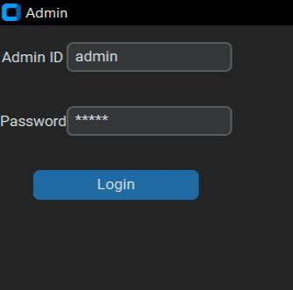
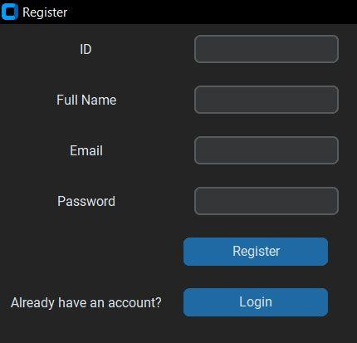
CHAPTER 6

RESULTS AND DISCUSSION

6.1 Snapshots of the project and description

Fig.6.1 Registration Page
Fig 6.1 shows registration for the user.

Fig.6.2 Admin Login Page
Fig 6.2 shows admin login for the user.

Dept. of ISE, BNMIT 2022-23 Page 18
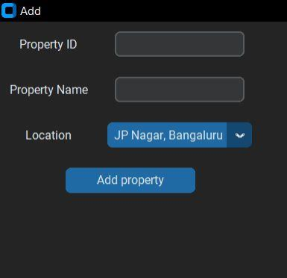
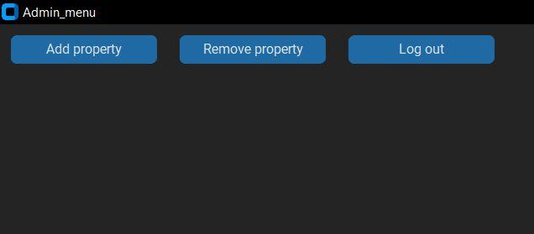
Implementation of Hashing with Buckets

Fig.6.3 Admin MENU Page
Fig 6.3 shows admin menu page with description Modules.

Fig.6.4 Add Property operations
Fig 6.4 shows add property of with these details.

Dept. of ISE, BNMIT 2022-23 Page 19
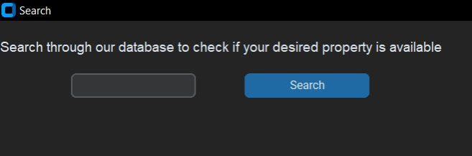
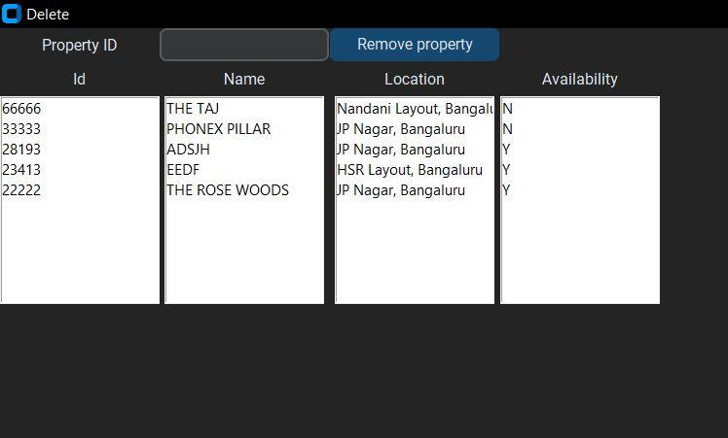
Implementation of Hashing with Buckets

Fig.6.5 Deletion operations
Fig 6.5 shows Deletion property of with these details.

Fig.6.6 Search operations
Fig 6.6 shows Search property of with these details.

Dept. of ISE, BNMIT 2022-23 Page 20
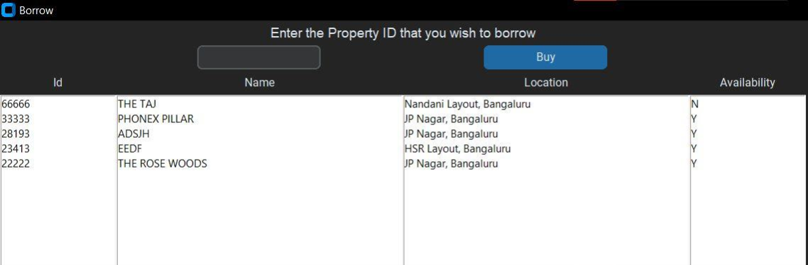
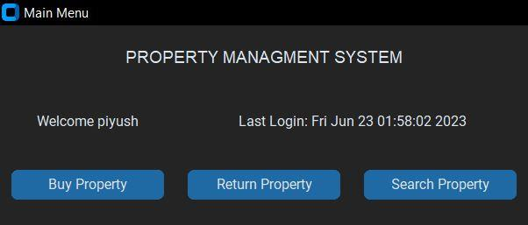
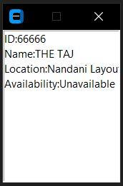
Implementation of Hashing with Buckets

Fig.6.7 Property Search Result
Fig 6.7 shows Search property with these results.

Fig.6.8 Main Menu operations
Fig 6.8 shows User property of with these details in main menu.

Fig.6.9 Buy Property operations
Fig 6.9 shows User to buy property with of available properties.

Dept. of ISE, BNMIT 2022-23 Page 21
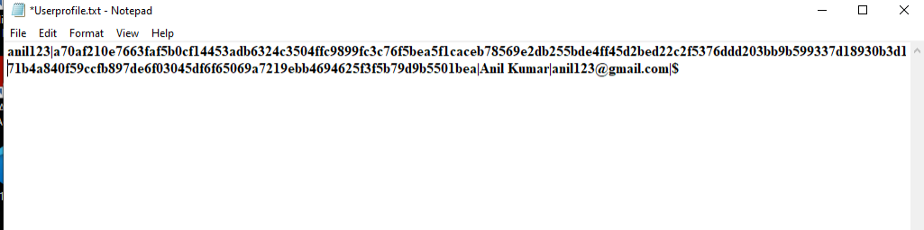
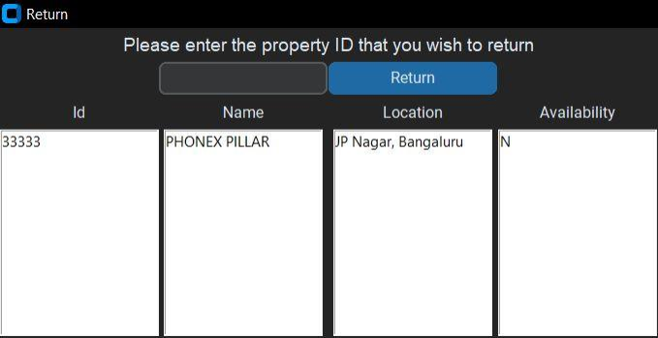
Implementation of Hashing with Buckets

Fig.6.10 Return Property operations
Fig 6.10 shows User to return property with of available properties.

Fig.6.11 User Credential details
Fig 6.11 shows User credential who will register the details.

Dept. of ISE, BNMIT 2022-23 Page 22
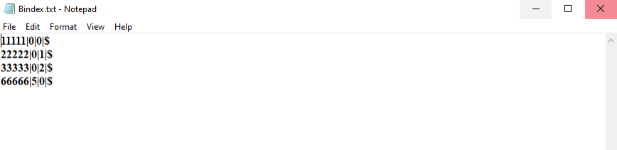
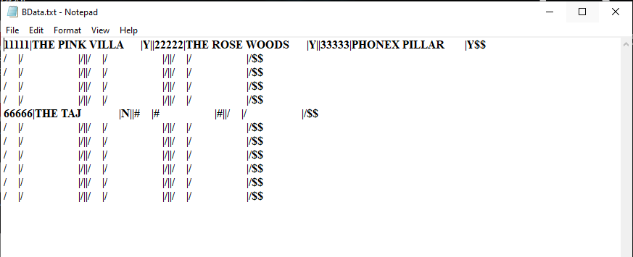
Implementation of Hashing with Buckets

Fig.6.12 Data save in Hash form

Fig 6.12 shows admin will deleted the record and show the hash at that record.

Fig.6.13 Record location Hash table form
Fig 6.13 shows admin will added the record with property id.

Dept. of ISE, BNMIT 2022-23 Page 23
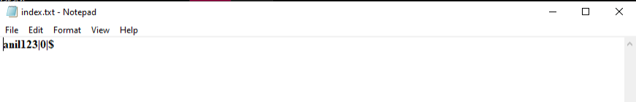
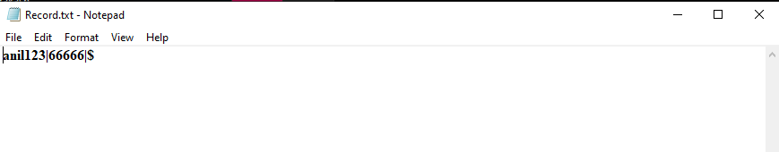
Implementation of Hashing with Buckets

Fig.6.14 Borrower & property Borrowed relationship

Fig 6.14 shows in this text file that property will borrow by any user.

Fig.6.15 Simple Indexing of user profile

Fig 6.14 shows the snapshot of the content stored in "index.txt" which stores the data of the users registered in alphabetical order with the offset value of the record where the user data is stored in the file "Userprofile.txt"

Dept. of ISE, BNMIT 2022-23 Page 24
Implementation of Hashing with Buckets

6.2 Observation about the project

The project is observed to correctly perform the operations of requirements like login, add property id, search property, delete property and update property. The details when entered by the Admin for addition of properties is appended to the data file. The admin can view whole file in the form in Borrow property. Admin can add any number of properties.
Point of the project is that the file handling parts are abstracted from the user and is used It is observed that hashinghas manyadvantages in filestructureorganization. Wecan observe that there is no limitation of hashing for number of fields in the text file. We can insert any number of inputs to the text file. Since it resolves the collision between the inputs by using buckets. Hash function generates a hash value based on which the value goes into either bucket1 or bucket2 and is also inserted into the text file.

6.3 Advantages of hashing with buckets

The biggest advantage of hashing is that it provides the ideal disk access time. Ideally hashing provides O (1) time complexity for disk access. Since the method directly maps the record to its actual address using the hash function, accessing the record would be easy by only providing the primary key to the hash function that would return the mapped address of that record. Hashing with buckets is also a collision resolution technique.

6.4 Disadvantages of hashing with buckets

The disadvantage of this method is that more than a single record could be mapped to the same address location causing collision Hence hashing with buckets is the collision resolution method. But, by doing so we are foregoing the direct disk access provided by hashing. As in this case we’ll have to traverse through the n number of buckets to find our record after obtaining the address from the hash function which is common to all buckets.

Dept. of ISE, BNMIT 2022-23 Page 25
Implementation of Hashing with Buckets

6.5 Applications of hashing with buckets

Hash buckets are used to apportion data items for sorting or lookup purposes, that it provides a lookup table mapping the required data with its address. The aim of this work is to weaken the linked lists so that searching for a specific item can be accessed within a shorter timeframe. A hash table that uses buckets is actually a combination of an array and a linked list.

Dept. of ISE, BNMIT 2022-23 Page 26
CHAPTER 7

CONCLUSION

The project generalizes the file structure operations such as insert, update, search and delete, by abstracting away the core functionality of the same and to implement the optimization method Hashing using buckets as collision resolution techniques on top of the same. The project helps the user to keep track of all the information on various property id in a simple and structured file system and can view the information stored in the files by retrieval of the records. This project also enables the user to add a new entry to the file and also retrieve details from the File. Insert module allows the admin to add new items into the data.txt file. Delete module enables the admin to delete a property item from the text file and the Search module allows admin to remove the values of a particular property id.

Dept. of ISE, BNMIT 2022-23 Page 27

REFERENCES

Text books

• Michael J.Folk, Bill Zoellick, File Structure, 2nd edition

• A.V. Oppenheim and R.W. Schafer, Digital Signal Processing, Englewood, N.J., Prentice Hall, 3 Edition, 1975.

Websites

• https://www.python.org/

• https://www.geeksforgeeks.org/hashing-data-structure • https://www.propertyangel.in/list-your-home.html
• https://www.researchgate.net/publication/305116511_The_Property_Management_S ystem_The_View_from_the_Front_Desk_on_Training_and_Performance

Dept. of ISE, BNMIT 2022-23 Page #

